**FUZZY WATER QUALITY SYSTEM PROJECT**

**Attribute Selection for Fuzzy Logic-Based Water Quality Assessment**

Since fuzzy logic simplifies decision-making by mimicking human reasoning, we should choose attributes that significantly impact water quality perception. Below is an evaluation of your collected attributes: 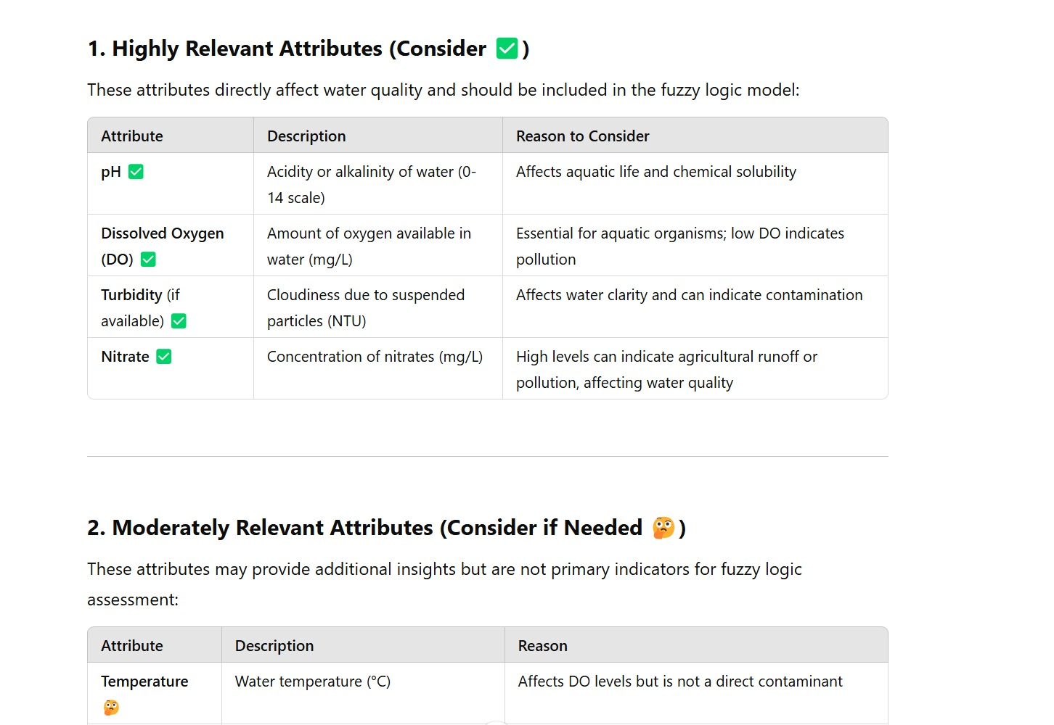

**Fuzzy sets** for these attributes based on the observed ranges:

**1. Temperature (°C) (Min: 2, Max: 38)**

* **Cold:** 2 - 15°C
* **Moderate:** 10 - 30°C
* **Warm:** 25 - 38°C

**2. Dissolved Oxygen (DO) (mg/L) (Min: 0.4, Max: 13.6)**

* **Low:** 0.4 - 4 mg/L
* **Moderate:** 3 - 8 mg/L
* **High:** 7 - 13.6 mg/L

**3. pH (Min: 6.0, Max: 9.9)**

* **Acidic:** 6.0 - 6.8
* **Neutral:** 6.5 - 8.0
* **Alkaline:** 7.8 - 9.9

**4. Biochemical Oxygen Demand (BOD) (mg/L) (Min: 0.1, Max: 105)**

* **Low Pollution:** 0.1 - 3 mg/L
* **Moderate Pollution:** 2 - 10 mg/L
* **High Pollution:** 8 - 105 mg/L

**5. Nitrate (mg/L) (Min: 0.03, Max: 11.9)**

* **Low:** 0.03 - 2 mg/L
* **Moderate:** 1.5 - 6 mg/L
* **High:** 5 - 11.9 mg/L

**Choosing Membership Functions for Fuzzy Sets**

We need to select appropriate **membership functions (MFs)** to define the fuzzy sets for **pH, DO, BOD, Nitrate, and Temperature**. The most commonly used membership functions are:

1. **Triangular :** Simple and widely used, good for **gradual transitions** between categories.
2. **Trapezoidal :** Used when **overlapping categories** are needed (gradual slopes at edges).
3. **Gaussian :** Used for **smooth transitions**, but requires mean and standard deviation.

**Best Choice: Triangular & Trapezoidal MFs**

For **our case**, we'll use:

* **Triangular** for parameters with well-defined breakpoints (e.g., pH, DO, Temperature).
* **Trapezoidal** where categories have **a wider middle range** (e.g., BOD and Nitrate).

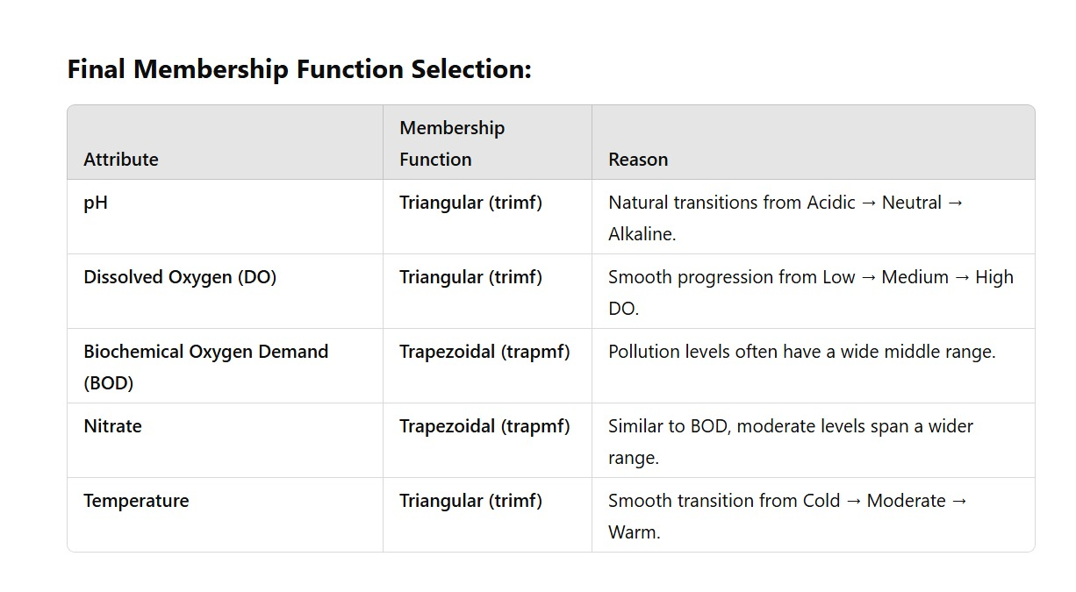

**Why Not Gaussian?**

* Gaussian is smooth but **not ideal** when we have fixed min-max breakpoints.
* Requires additional parameters (mean, standard deviation), which we don’t need here.

